VOLUME 2
ROBOT KINEMATICS AND
DH PARAMETERS
Robot Kinematics | Transformation Matrices | DH Parameters | 2-DOF Robotic Arm
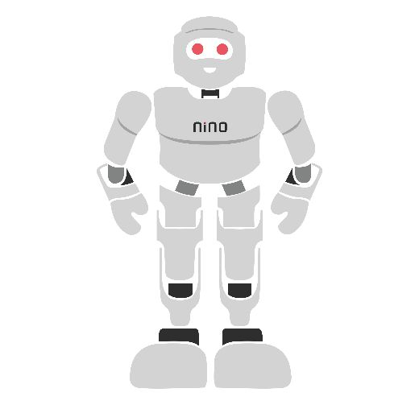

Module Overview
Every robot that picks, places, welds, paints or draws must answer one basic question: "If I set my joints to these angles, where exactly is my hand?" The branch of robotics that answers this question is called kinematics. This module builds that skill from zero. It starts with what a robot arm is made of, then teaches the mathematical language robots use to describe position and direction (coordinate frames and transformation matrices), then introduces the industry-standard recipe for describing any robot arm with four numbers per joint (Denavit–Hartenberg or DH parameters), and finally applies everything to a real 2-DOF (two-degree-of-freedom) planar robotic arm.
Every idea is first explained in plain language, then with a picture, and only then with an equation. Each equation is followed by a worked numerical example that you can check on a calculator. The practical part uses free software (Python in a browser through Google Colab, or a spreadsheet), so every learner can complete it without special hardware. An optional hardware build re-uses the Arduino Uno and SG90 servos from the Semester 1 microcontroller module. Taught end-to-end, the module is designed to fill approximately 28–32 hours of instruction and practice.
# | Topic | Hands-on Focus
1 | Introduction to Robot Kinematics | Identify links, joints and DOF of real robots
2 | Coordinate Frames and Transformation Matrices | Lab 1: Translation and rotation in Python
3 | Denavit–Hartenberg (DH) Parameters | Lab 2: DH table and forward-kinematics calculator
4 | Forward Kinematics of a 2-DOF Planar Arm | Lab 3: Visualise and verify a 2-DOF arm
5 | Practical Lab Exercises (Labs 1–3 with model solutions) | Python / spreadsheet; optional servo arm
6 | Integrated Mini-Project: 2-DOF FK Visualiser | Interactive slider visualiser + test cases
7–8 | Troubleshooting, Assessment and Revision | Formula sheet, questions, rubric

Learning Outcomes
By the end of this module, learners will be able to:
- Explain the terms link, joint, degree of freedom, joint variable, end effector and workspace, and identify them on a real robot.
- Distinguish forward kinematics from inverse kinematics and state which one this module solves.
- Construct 2D and 3D translation and rotation matrices and combine them into homogeneous transformation matrices.
- Calculate the coordinates of a point after a chain of transformations, multiplying matrices in the correct order.
- Assign DH coordinate frames to a serial robot and build a DH parameter table (a, α, d, θ) with correct units and signs.
- Derive the forward-kinematics equations of a 2-DOF planar arm both geometrically and with DH matrices, and verify that the two methods agree.
- Implement a forward-kinematics calculator in Python or a spreadsheet and visualise the arm and its workspace.
- Troubleshoot common errors such as degree/radian mix-ups, wrong multiplication order and inconsistent DH conventions.
Hardware and Software Required
Essential items (needed by every learner):
Item | Purpose | Notes
PC or laptop (Windows, macOS or Linux) with internet | Run Python or a spreadsheet | Any machine from the last 8 years is enough
Python 3.10+ with NumPy and Matplotlib, or Google Colab | Matrix calculations and plots | Colab runs in a browser; nothing to install
Spreadsheet (LibreOffice Calc, Google Sheets or Excel) | No-code forward-kinematics calculator | Free options available
A4 graph paper (1 cm grid), ruler, protractor, pencil | Draw frames, measure positions | Used in every lab
Cardboard strips or ice-cream sticks, two split pins | Paper model of a 2-DOF arm | Zero-cost physical model

Optional items (for the hardware extension of Lab 3 and the mini-project):
Item | Purpose | Free alternative
Arduino Uno R3 + USB cable | Command the servo joints | Wokwi simulator (wokwi.com)
2 × SG90 micro servos, servo horns, screws | Joint 1 (shoulder) and joint 2 (elbow) | Paper model with protractor
4 × AA battery pack (6 V), jumper wires, breadboard | Separate servo supply, common ground | —
GNU Octave or MATLAB (Robotics System Toolbox) | Alternative to Python | GNU Octave (free, no toolbox needed)
Robotics Toolbox for Python (Peter Corke) | Cross-check DH models | Own NumPy code from Lab 2

Safety and equipment care
Servos can pinch fingers: keep hands clear when a sketch is running and power servos from the battery pack, never from the Uno 5 V pin. Join all grounds.
Use blunt pencils or a felt pen as the 'end effector'. Never fix sharp tools to a hobby arm. Switch off power before adjusting links or horns.

1. Introduction to Robot Kinematics

1.1 What Is a Robot and a Robotic Manipulator?
A robot is a machine that can sense, decide and act on its own according to a program. A robotic manipulator (or robot arm) is the most common industrial robot: a chain of rigid parts connected by motorised joints, fixed at one end (the base) and carrying a tool at the other end. Car factories use arms for welding and painting, electronics plants use them to place components, hospitals use them for surgery and warehouses use them to pick parcels.
Kinematics is the study of motion without thinking about the forces that cause it. A useful analogy: kinematics is like a map and directions (where am I and how do I get there), while dynamics is like the engine and fuel (how much force is needed). This module covers only kinematics.

1.2 Links, Joints and Degrees of Freedom
A robot arm is described with a small set of words. Learn them now, because every later section uses them:
- Link — a rigid part of the arm, like a bone. The fixed base is called link 0; the moving links are numbered 1, 2, 3… outwards.
- Joint — a connection between two links that allows motion, like an elbow. Joint i connects link i−1 to link i.
- End effector — the tool at the end of the arm: a gripper, suction cup, welding torch or pen.
- Degree of freedom (DOF) — one independent way the arm can move. For a simple serial arm, DOF = number of 1-DOF joints.
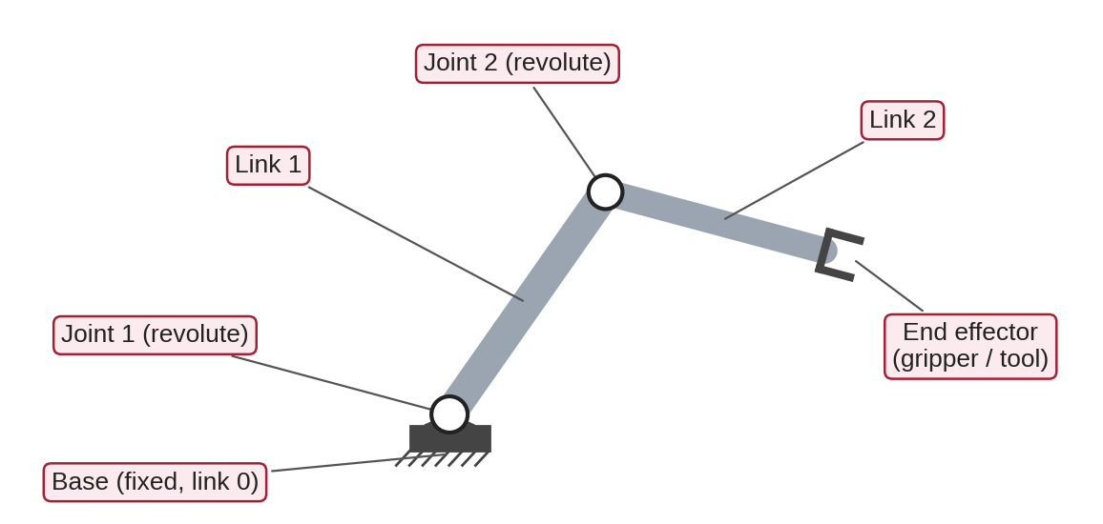
Figure 1.1: Anatomy of a 2-DOF robot arm: a fixed base, two revolute joints, two links and an end effector.
Robots mostly use two kinds of joint (Figure 1.2). A revolute joint (R) rotates like a door hinge; its position is an angle θ measured in degrees (°) or radians (rad). A prismatic joint (P) slides like a drawer; its position is a distance d measured in metres (m) or millimetres (mm). The number that a motor changes to move a joint is called the joint variable (θ for R joints, d for P joints).
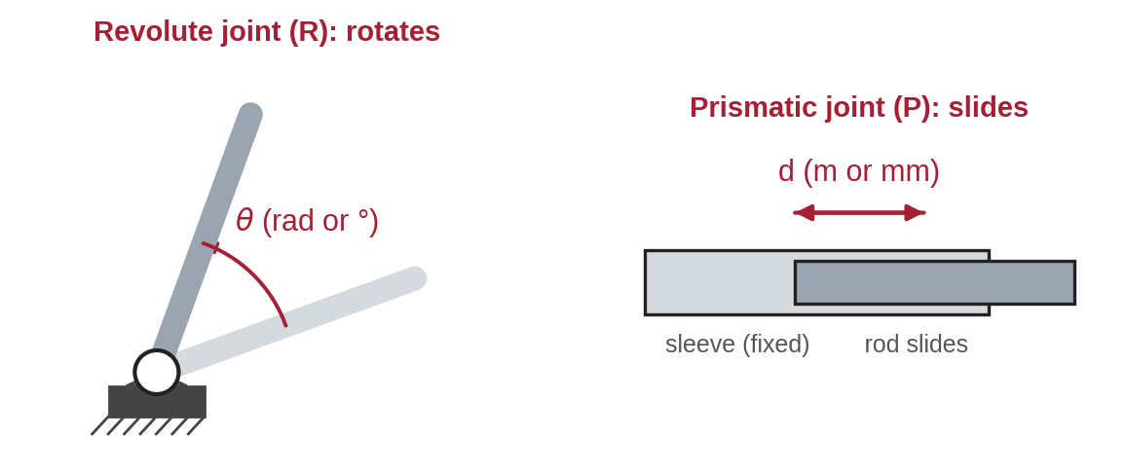
Figure 1.2: The two basic joint types: a revolute joint changes an angle θ, a prismatic joint changes a length d.
A free object in 3D space has 6 DOF: three to choose its position (x, y, z) and three to choose its orientation (roll, pitch, yaw). That is why most industrial arms have six joints. A robot that moves only in a flat plane needs at most 3 DOF (x, y and one rotation angle φ).
Everyday and industrial examples (joint types listed from base to tool): a desk lamp with two hinges and our planar teaching arm are R R, 2 DOF; a SCARA assembly robot is R R P R, 4 DOF; a 3D printer or Cartesian gantry is P P P, 3 DOF; a cylindrical machine-loading robot is R P P, 3 DOF (worked in Section 3.6); a welding or painting robot is 6R, 6 DOF; and the human arm (shoulder, elbow, wrist) has about 7 DOF — the extra one gives it flexibility to reach around obstacles.

1.3 Joint Space, Task Space and the Workspace
There are two ways to describe what a robot is doing. In joint space we list the joint variables, for example θ₁ = 30°, θ₂ = 45°. In task space (also called Cartesian space) we describe where the end effector is and which way it points, for example x = 10.47 cm, y = 11.76 cm, φ = 75°. Humans think in task space ("put the cup there"); motors work in joint space. Kinematics is the bridge between them.
The workspace is the set of all points the end effector can reach. Its shape depends on the link lengths and on the joint limits. You will calculate the workspace of the 2-DOF arm in Section 4.7.

1.4 Forward vs Inverse Kinematics
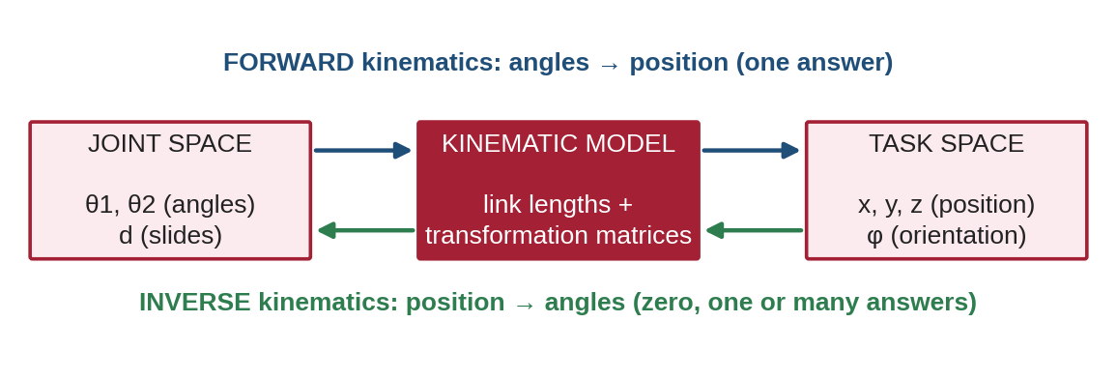
Figure 1.3: Forward kinematics maps joint values to the end-effector pose; inverse kinematics works in the opposite direction.
Forward kinematics (FK) answers: given the joint values, where is the end effector? It always has exactly one answer and is solved by multiplying matrices — this is the main subject of this module. Inverse kinematics (IK) answers the reverse question: which joint values place the end effector at a target point? IK may have no answer (target out of reach), one answer, or several (for example, "elbow-up" and "elbow-down" postures). IK is introduced only briefly here and is studied fully in a later module.

1.5 Coordinate Frames: Position and Orientation
To say where something is, we need a reference. A coordinate frame is a reference made of an origin (a point) and perpendicular axes (x, y, z). Frames are written in curly brackets: {0} is the base frame fixed to the ground, {1} is attached to link 1, and so on. The full description of an object relative to a frame is called its pose, which has two parts:
- Position — where the object’s origin is: a vector p = (x, y, z) in metres or centimetres.
- Orientation — which way the object points: in a plane this is a single angle φ; in 3D it is described by a rotation matrix (Section 2).
Example: a pen tip at x = 3.0 cm, y = 1.8 cm in {0}, pointing 35° anticlockwise from x₀, has position p = (3.0, 1.8) cm and orientation φ = 35°. Section 2 shows how to write both parts in one matrix.

1.6 Common Mistakes to Avoid
- Counting the gripper opening/closing as an arm DOF — it moves the fingers, not the position of the hand.
- Forgetting to say which frame a position is measured in — "(3, 2)" means nothing without "in frame {0}".

2. Coordinate Frames and Transformation Matrices

2.1 2D and 3D Frames and the Right-Hand Rule
In 2D a frame has an x-axis and a y-axis at 90° to each other. In 3D a third axis, z, is added. To avoid confusion, robotics always uses a right-handed frame: point the thumb of your right hand along x, the index finger along y, and the middle finger then shows +z (Figure 2.1). The same rule fixes the sign of angles: curling the right-hand fingers from x towards y is a positive (counter-clockwise) rotation about z. In a 2D drawing, +z points out of the page towards you.
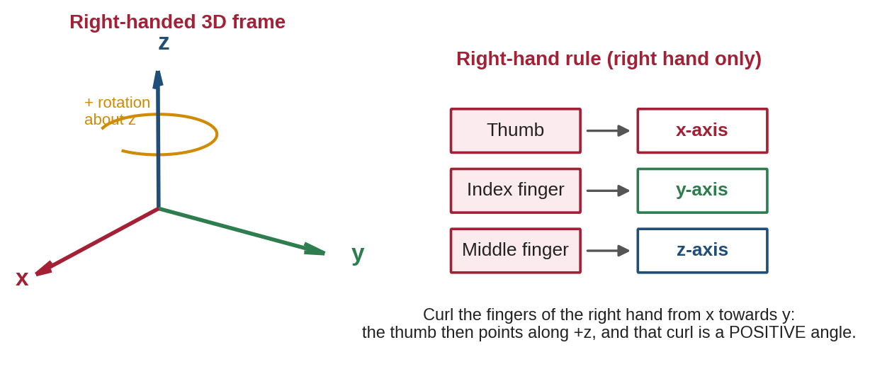
Figure 2.1: A right-handed coordinate frame and the right-hand rule used for axis directions and positive rotations.

2.2 Translation: Moving Without Turning
A translation shifts a frame without turning it. If frame {1} is parallel to {0} and its origin sits at t = (tₓ, t_y) in {0}, a point P with coordinates (x₁, y₁) in {1} has these coordinates in {0}:
x₀ = x₁ + tₓ y₀ = y₁ + t_y(2.1)
Worked example 2.1. In Figure 2.2, {1} is shifted by t = (4, 1.5). Point P is at (0.8, 0.6) in {1}. In {0}: x₀ = 0.8 + 4 = 4.8 and y₀ = 0.6 + 1.5 = 2.1.
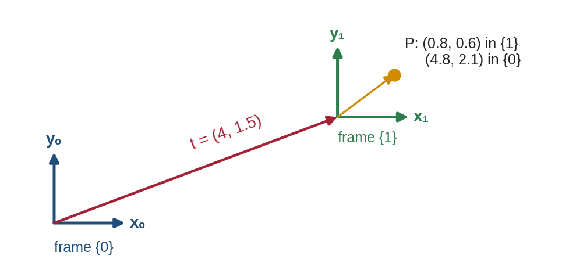
Figure 2.2: Translation: frame {1} is a parallel copy of frame {0} shifted by the vector t.

2.3 Rotation Matrices
A rotation turns a frame about an axis without moving its origin. Suppose frame {1} is turned by angle θ about z (Figure 2.3). Basic trigonometry gives the coordinates in {0} of a point (x₁, y₁) known in {1}:
x₀ = x₁ cos θ − y₁ sin θ y₀ = x₁ sin θ + y₁ cos θ(2.2)
Writing these two equations as a matrix multiplication gives the 2D rotation matrix R(θ). Its first column is the x₁-axis drawn in {0} and its second column is the y₁-axis drawn in {0}:

R(θ) = |  | cos θ | −sin θ
R(θ) = |  | sin θ | cos θ

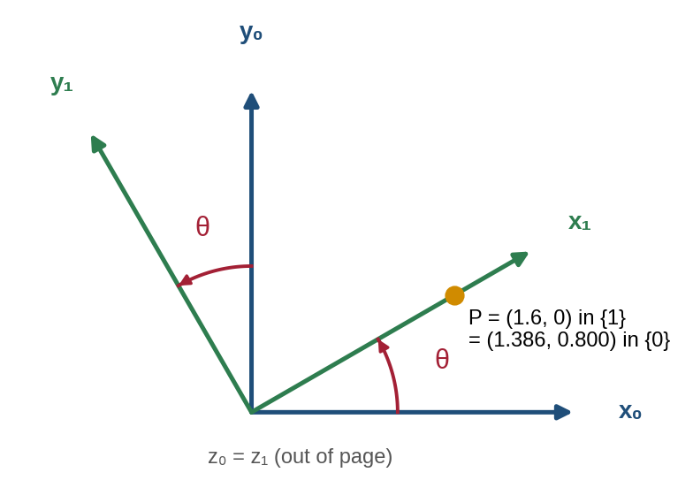
Figure 2.3: Rotation of frame {1} by θ = 30° about the common z-axis; point P is expressed in both frames.
Worked example 2.2. θ = 30°, so cos 30° = 0.866 and sin 30° = 0.500. Point P = (1.6, 0) in {1}. Then x₀ = 1.6 × 0.866 − 0 × 0.5 = 1.386 and y₀ = 1.6 × 0.5 + 0 × 0.866 = 0.800. The distance from the origin is unchanged (√(1.386² + 0.8²) = 1.6): rotations never change lengths.
In 3D there is one basic rotation matrix for each axis. The axis you rotate about keeps its "1" on the diagonal, because coordinates along that axis do not change:

R_x(θ) = |  | 1 | 0 | 0 |  |  | R_y(θ) = |  | cos θ | 0 | sin θ
R_x(θ) = |  | 0 | cos θ | −sin θ |  |  | R_y(θ) = |  | 0 | 1 | 0
R_x(θ) = |  | 0 | sin θ | cos θ |  |  | R_y(θ) = |  | −sin θ | 0 | cos θ

R_z(θ) = |  | cos θ | −sin θ | 0
R_z(θ) = |  | sin θ | cos θ | 0
R_z(θ) = |  | 0 | 0 | 1

Every rotation matrix has three useful properties that you can use to check your work: (1) each column has length 1; (2) the columns are perpendicular to each other; (3) its inverse equals its transpose, R⁻¹ = Rᵀ, and its determinant is +1. If a matrix you calculate fails these checks, there is an arithmetic or sign error.

2.4 Homogeneous Coordinates and the Homogeneous Transformation Matrix
A robot joint usually both rotates and translates a frame. We could handle rotation with a matrix and translation with an addition, but chaining many such steps becomes messy. The trick used in robotics is to add an extra "1" to every point: (x, y) becomes (x, y, 1) in 2D and (x, y, z) becomes (x, y, z, 1) in 3D. These are called homogeneous coordinates. With this extra number, rotation and translation fit into a single square matrix called the homogeneous transformation matrix (HTM), written T.
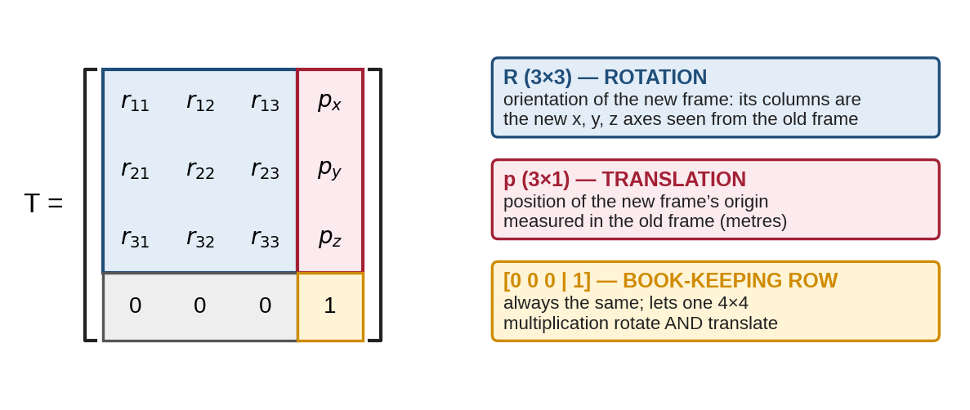
Figure 2.4: Breakdown of a 4 × 4 homogeneous transformation matrix into rotation R, translation p and the fixed bottom row.
In 2D the HTM is 3 × 3 and in 3D it is 4 × 4. The basic 3D building blocks are a pure translation and a pure rotation (shown here about z):

Trans(a, b, c) = |  | 1 | 0 | 0 | a |  |  | Rot_z(θ) = |  | cos θ | −sin θ | 0 | 0
Trans(a, b, c) = |  | 0 | 1 | 0 | b |  |  | Rot_z(θ) = |  | sin θ | cos θ | 0 | 0
Trans(a, b, c) = |  | 0 | 0 | 1 | c |  |  | Rot_z(θ) = |  | 0 | 0 | 1 | 0
Trans(a, b, c) = |  | 0 | 0 | 0 | 1 |  |  | Rot_z(θ) = |  | 0 | 0 | 0 | 1

Worked example 2.3 (rotation + translation together). Frame {1} is rotated 30° about z and its origin is at (4, 1.5) in {0}. A point is at (2, 1) in {1}. Using the 2D HTM:

⁰P = |  | 0.866 | −0.500 | 4 |  | × |  | 2 |  | = |  | 5.232
⁰P = |  | 0.500 | 0.866 | 1.5 |  | × |  | 1 |  | = |  | 3.366
⁰P = |  | 0 | 0 | 1 |  | × |  | 1 |  | = |  | 1

Row 1: 0.866 × 2 − 0.5 × 1 + 4 × 1 = 5.232. Row 2: 0.5 × 2 + 0.866 × 1 + 1.5 × 1 = 3.366. So the point is at (5.232, 3.366) in {0}. The last "1" stays 1 — a quick check that the bottom row was written correctly.

2.5 Chaining Transformations: Order Matters
If {1} is described relative to {0} by ⁰T₁, and {2} is described relative to {1} by ¹T₂, then {2} relative to {0} is found by multiplying:
⁰T₂ = ⁰T₁ · ¹T₂(2.3)
A simple memory aid: the inner indices "cancel" (⁰T₁ ¹T₂ → ⁰T₂), just like fractions. Matrix multiplication is not commutative: A·B is usually different from B·A. Reading a product from left to right, each new matrix is applied along the axes of the frame you have just arrived at (the current or moving frame). Figure 2.5 shows the same two operations in two orders giving two different results — you will reproduce this in Lab 1.
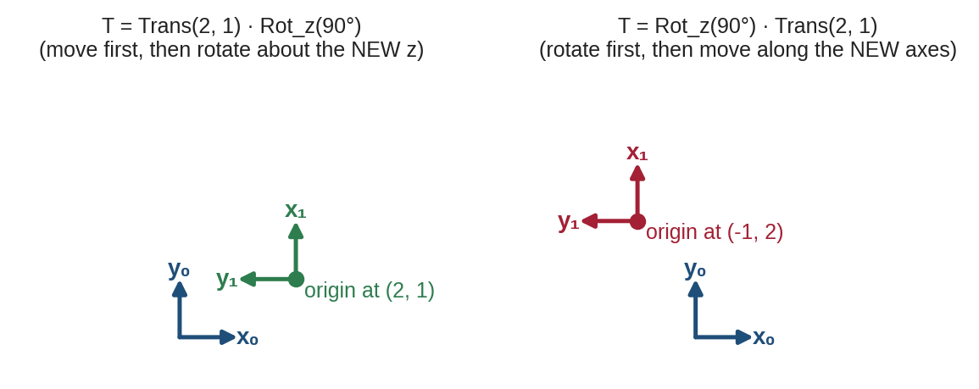
Figure 2.5: Trans·Rot and Rot·Trans place frame {1} in different positions: multiplication order changes the result.
Dimension check: an (m × n) matrix can only multiply an (n × k) matrix, giving (m × k). A 4 × 4 HTM times a 4 × 1 point gives a 4 × 1 point; a 4 × 4 times a 4 × 4 gives another 4 × 4 HTM.

2.6 Inverse of a Transformation
Sometimes we need the reverse description: where is {0} as seen from {1}? Because R⁻¹ = Rᵀ, the inverse of an HTM is cheap to compute without a general matrix inverse:

T⁻¹ = |  | Rᵀ | −Rᵀp
T⁻¹ = |  | 0 0 0 | 1

Check: applying the inverse of the transform from Worked example 2.3 to (5.232, 3.366) must return (2, 1). Always verify an inverse by checking that T · T⁻¹ gives the identity matrix I (1s on the diagonal, 0s elsewhere).

2.7 Common Mistakes to Avoid
- Writing sin where cos belongs (or a missing minus sign) in a rotation matrix — check that each column has length 1.
- Using a left-handed frame (x right, y up, z into the page) — z must come out of the page.
- Multiplying in the wrong order, or using T where T⁻¹ was needed.
- Forgetting the final "1" in homogeneous coordinates, so the translation is silently ignored.

3. Denavit–Hartenberg (DH) Parameters

3.1 Why We Need a Convention
A transformation between two neighbouring links could be written with up to six numbers (three for position, three for orientation), and every engineer could place the frames differently. In 1955, Jacques Denavit and Richard Hartenberg proposed a set of rules — the DH convention — that places the frames in a standard way so that each link needs only four numbers. Because everyone follows the same rules, a robot can be described by a short table instead of pages of drawings, and the same computer code can compute the kinematics of any serial arm.
Convention used in this module
This module uses the standard (distal) DH convention as presented by Spong, Hutchinson and Vidyasagar. Frame {i} is fixed to the far (distal) end of link i, and z₍ᵢ₋₁₎ lies along the axis of joint i. Some books (for example Craig) use the modified (proximal) DH convention, which places frames differently and gives different tables for the same robot. Both are correct, but never mix them. Every table and matrix in this module uses standard DH.

3.2 The Four DH Parameters
Going from frame {i−1} to frame {i} always uses the same four simple moves, done in this exact order: rotate about z, slide along z, slide along x, twist about x. Each move has one parameter:
Symbol | Name | Plain-language meaning | Measured along / about | Unit
θᵢ | Joint angle | How much to turn x₍ᵢ₋₁₎ to line it up with xᵢ | about z₍ᵢ₋₁₎ | rad or °
dᵢ | Link offset | How far to slide up z₍ᵢ₋₁₎ to reach the xᵢ line | along z₍ᵢ₋₁₎ | m, cm or mm
aᵢ | Link length | Shortest distance between joint axes z₍ᵢ₋₁₎ and zᵢ | along xᵢ | m, cm or mm
αᵢ | Link twist | How much the next joint axis is tilted relative to the previous one | about xᵢ | rad or °

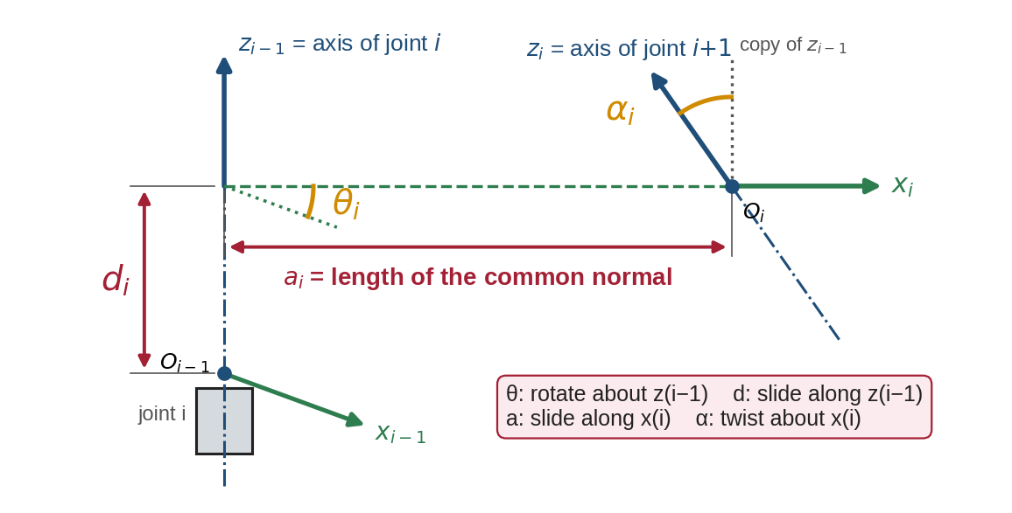
Figure 3.1: Geometric meaning of the four DH parameters between joint axis z₍ᵢ₋₁₎ and joint axis zᵢ.
Two of the parameters, aᵢ and αᵢ, depend only on the shape of the link — they are fixed once the robot is built. The other two, θᵢ and dᵢ, describe the joint. For each joint exactly one of them changes when the joint moves:
Joint type | Joint variable (changes) | Constants | Example
Revolute (R) | θᵢ | aᵢ, αᵢ, dᵢ | Servo shoulder of a 2-DOF arm
Prismatic (P) | dᵢ | aᵢ, αᵢ, θᵢ | Vertical slide of a cylindrical robot

In a DH table the joint variable is often marked with an asterisk, for example θ₁*, so the reader can see at a glance which entries change.

3.3 The DH Frame-Assignment Procedure
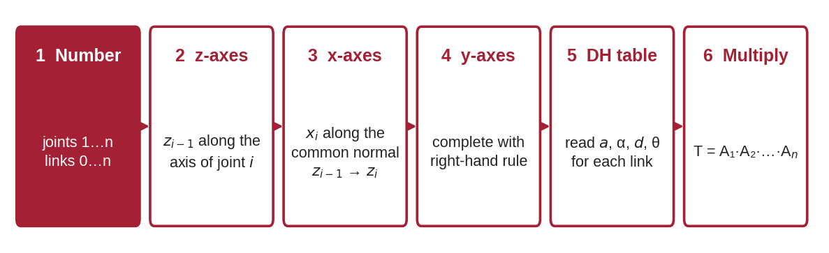
Figure 3.2: The six-step DH frame-assignment procedure.
- Number the joints and links. The base is link 0. Joint i connects link i−1 to link i. A robot with n joints has frames {0} to {n}.
- Place the z-axes. Put z₍ᵢ₋₁₎ along the axis of joint i: the rotation axis of a revolute joint, or the sliding direction of a prismatic joint. Choose its positive direction (either is allowed; positive θ then follows the right-hand rule).
- Place the base frame {0}. Its origin can be anywhere on z₀; choose x₀ to make the table simple (usually pointing along link 1 when θ₁ = 0).
- Place each xᵢ along the common normal — the line that meets both z₍ᵢ₋₁₎ and zᵢ at 90°. Its origin Oᵢ is where that line meets zᵢ. Special cases: if the z-axes intersect, aᵢ = 0 and xᵢ is perpendicular to both; if they are parallel, any common normal can be chosen (pick the one that makes dᵢ = 0).
- Complete each frame with yᵢ using the right-hand rule (yᵢ = zᵢ × xᵢ). The y-axes never appear in the table.
- Place the end-effector frame {n}. Its x-axis must still be perpendicular to z₍ₙ₋₁₎; choose zₙ along the tool’s approach direction where possible.
- Read the table: for each link, measure θᵢ, dᵢ, aᵢ, αᵢ using the definitions in Section 3.2, with signs from the right-hand rule.

3.4 The Standard DH Transformation Matrix
The four moves of Section 3.2 are four basic transformations, multiplied in order (each move is along the current axes, so we multiply left to right):
Aᵢ = Rot_z(θᵢ) · Trans_z(dᵢ) · Trans_x(aᵢ) · Rot_x(αᵢ)(3.1)
Multiplying the four 4 × 4 matrices gives the standard DH link matrix, the single most important equation of this module:

Aᵢ = |  | cos θᵢ | −sin θᵢ cos αᵢ | sin θᵢ sin αᵢ | aᵢ cos θᵢ
Aᵢ = |  | sin θᵢ | cos θᵢ cos αᵢ | −cos θᵢ sin αᵢ | aᵢ sin θᵢ
Aᵢ = |  | 0 | sin αᵢ | cos αᵢ | dᵢ
Aᵢ = |  | 0 | 0 | 0 | 1

What each symbol means: θᵢ = joint angle; dᵢ = link offset; aᵢ = link length; αᵢ = link twist (all defined in Section 3.2). The top-left 3 × 3 block is the rotation of {i} relative to {i−1}; the right-hand column (aᵢ cos θᵢ, aᵢ sin θᵢ, dᵢ) is the position of origin Oᵢ in frame {i−1}. Once every Aᵢ is known, the pose of the end effector in the base frame is simply:
⁰Tₙ = A₁ · A₂ · … · Aₙ(3.2)

3.5 Quick Self-Checks for DH Tables
Check | How to test it | Typical error it catches
Zero-angle pose | Set all θ = 0 and sketch the arm; does it match the frames you drew? | Wrong x₀ direction or offset
One variable per joint | Each row has exactly one starred entry | Treating a constant as a variable
Units | All a and d in the same unit; angles all in rad inside code | Answers 100× or 57.3× too big
Twist sign | Rotate z₍ᵢ₋₁₎ about +xᵢ with the right hand; does it reach zᵢ? | α = +90° written as −90°
Length sanity | Distance base → tool ≤ sum of all aᵢ and dᵢ | Missing link or wrong value
Same convention | All rows use standard (not modified) DH | Mixed textbook formulas

3.6 Fully Worked Example: A 3-DOF Cylindrical Robot (R-P-P)
The cylindrical robot of Figure 3.3 has a vertical column that rotates (joint 1, angle θ₁), a carriage that slides up and down the column (joint 2, distance d₂) and an arm that slides in and out horizontally (joint 3, distance d₃). The fixed height from the floor to the first frame is d₁. It is a good DH example because it contains both joint types and a non-zero twist.
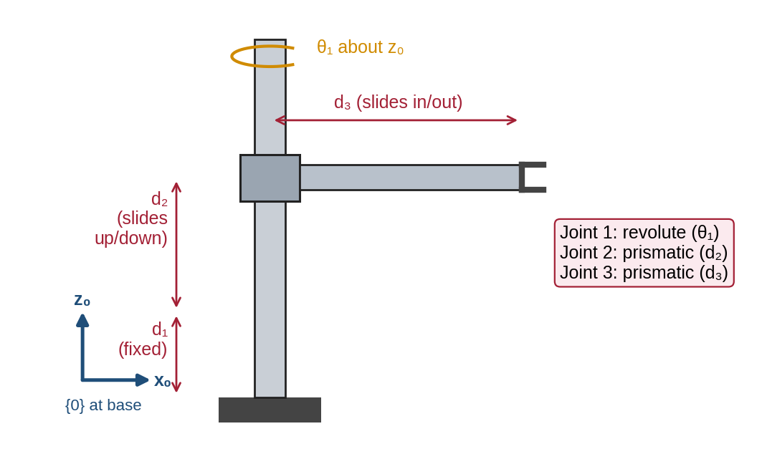
Figure 3.3: A cylindrical R-P-P robot with one revolute and two prismatic joints.
Step 1–2 (axes). Joint 1 rotates about the vertical, so z₀ is vertical. Joint 2 slides vertically, so z₁ is also vertical (it coincides with z₀). Joint 3 slides horizontally along the arm, so z₂ points along the arm. The tool frame {3} is placed at the gripper with z₃ along z₂.
Step 3–4 (x-axes and parameters). Link 1: z₀ and z₁ coincide, so a₁ = 0 and α₁ = 0; O₁ is d₁ above O₀ and θ₁ is the variable. We choose x₁ so that, when θ₁ = 0, the arm points along x₀. Link 2: z₁ (vertical) and z₂ (horizontal) intersect, so a₂ = 0 and x₂ is perpendicular to both. Rotating x₁ by +90° about z₁ lines it up with x₂, so θ₂ = +90° (constant). Rotating z₁ by +90° about x₂ turns it to point along the arm, so α₂ = +90°. The carriage height d₂ is the variable. Link 3: z₂ and z₃ are the same line, so a₃ = 0, α₃ = 0, θ₃ = 0 and d₃ is the variable.
Link i | aᵢ | αᵢ | dᵢ | θᵢ | Variable
1 | 0 | 0° | d₁ (constant) | θ₁* | θ₁
2 | 0 | +90° | d₂* | +90° (constant) | d₂
3 | 0 | 0° | d₃* | 0° | d₃

Step 5–6 (matrices). Substituting each row into the DH matrix and multiplying A₁·A₂·A₃ (writing c₁ = cos θ₁, s₁ = sin θ₁) gives:

⁰T₃ = |  | −s₁ | 0 | c₁ | d₃ c₁
⁰T₃ = |  | c₁ | 0 | s₁ | d₃ s₁
⁰T₃ = |  | 0 | 1 | 0 | d₁ + d₂
⁰T₃ = |  | 0 | 0 | 0 | 1

Read the answer: the gripper is at x = d₃ cos θ₁, y = d₃ sin θ₁, z = d₁ + d₂. This makes physical sense: the arm reaches out a distance d₃ in the direction θ₁, at height d₁ + d₂. The third column (c₁, s₁, 0) is z₃, which points along the arm — also correct.
Numerical check. With θ₁ = 30°, d₁ = 20 cm, d₂ = 10 cm and d₃ = 15 cm: x = 15 × 0.866 = 12.99 cm, y = 15 × 0.5 = 7.50 cm, z = 20 + 10 = 30 cm. The horizontal reach √(12.99² + 7.5²) = 15.0 cm equals d₃, as it must.

3.7 Common Mistakes to Avoid
- Putting zᵢ (instead of z₍ᵢ₋₁₎) on the axis of joint i — this shifts every row of the table by one.
- Measuring θᵢ about xᵢ, or αᵢ about zᵢ — θ and d belong to z, a and α belong to x.
- Forgetting that a twist of 90° makes cos α = 0 and sin α = 1 (or −1); sign errors here flip the whole arm.
- Copying a modified-DH table from one book into the standard-DH matrix from another.

4. Forward Kinematics of a 2-DOF Planar Robotic Arm

4.1 The Robot
We now apply everything to the arm used in the labs: two revolute joints with parallel vertical axes, so the arm moves in a flat horizontal (or vertical) plane, like a desk lamp. The symbols are:
- L₁, L₂ — link lengths between joint centres (this module uses L₁ = 10 cm, L₂ = 7 cm).
- θ₁ — angle of link 1 measured from the base x₀-axis, counter-clockwise positive.
- θ₂ — angle of link 2 measured relative to link 1 (from the extension of link 1), counter-clockwise positive. θ₂ = 0 means the arm is straight.
- (x, y) — end-effector position in the base frame {0}; φ — its orientation angle.
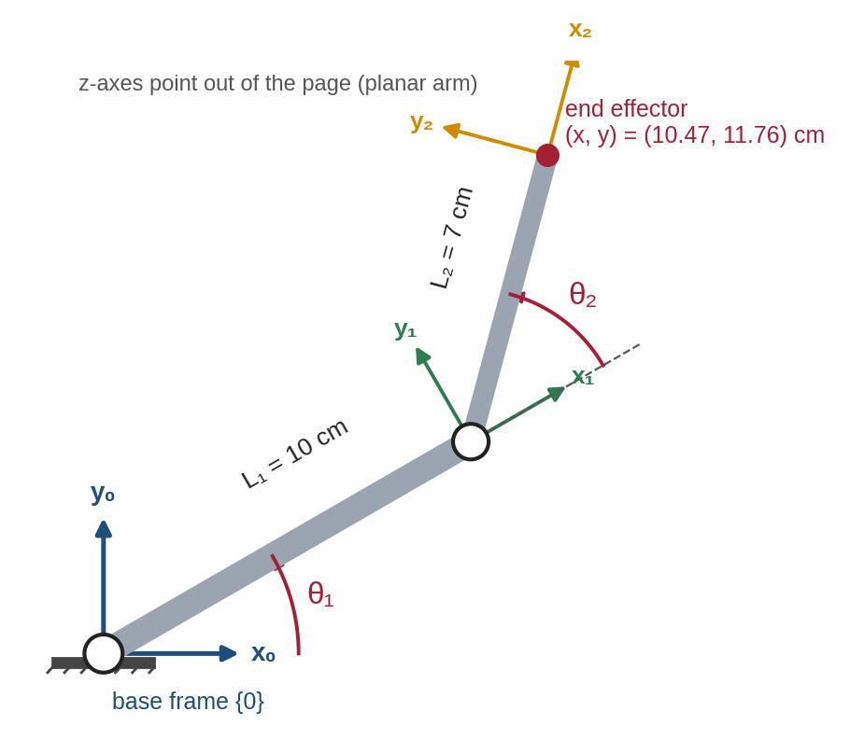
Figure 4.1: 2-DOF planar arm with link lengths L₁, L₂, joint angles θ₁, θ₂, DH frames {0}, {1}, {2} and the end effector (θ₁ = 30°, θ₂ = 45°).

4.2 Geometric Derivation (Step by Step)
Before using matrices, derive the answer with simple trigonometry — it gives a result to check the matrices against.
- Link 1 points at angle θ₁, so the elbow (joint 2) is at x = L₁ cos θ₁, y = L₁ sin θ₁.
- Link 2 is turned θ₂ further than link 1, so its absolute angle from x₀ is (θ₁ + θ₂).
- Link 2 therefore adds L₂ cos(θ₁ + θ₂) to x and L₂ sin(θ₁ + θ₂) to y.
- The tool’s orientation equals the absolute angle of the last link.
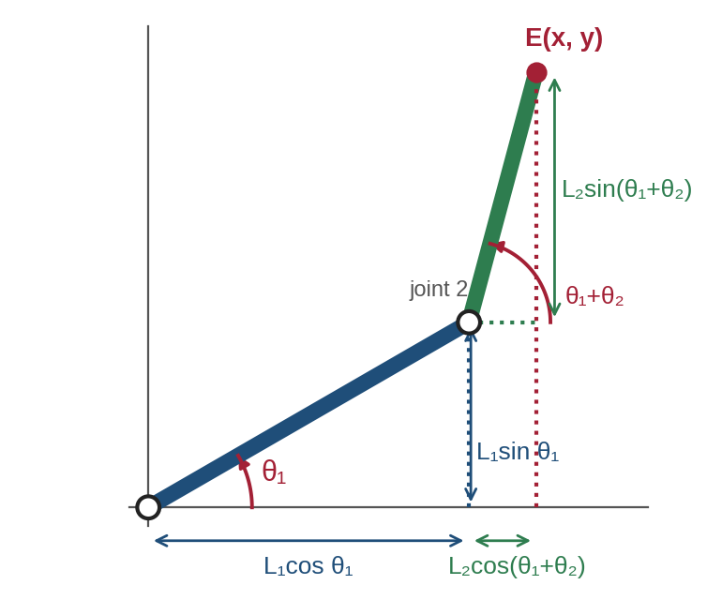
Figure 4.2: Geometric derivation: the end-effector position is the sum of the projections of the two links.
x = L₁ cos θ₁ + L₂ cos(θ₁ + θ₂)(4.1)
y = L₁ sin θ₁ + L₂ sin(θ₁ + θ₂)(4.2)
φ = θ₁ + θ₂(4.3)

4.3 DH Frame Assignment and DH Table
Both joint axes point out of the page, so z₀ (axis of joint 1) and z₁ (axis of joint 2) are parallel. Following Section 3.3: {0} is at joint 1 with x₀ along the zero-angle direction; x₁ lies along the common normal between z₀ and z₁, which is link 1 itself, with O₁ at joint 2; {2} is placed at the tool tip with x₂ along link 2 (Figure 4.1). Every z-axis is parallel, so all twists are zero and all offsets are zero:
Link i | aᵢ (cm) | αᵢ | dᵢ (cm) | θᵢ | Joint type
1 | L₁ = 10 | 0° | 0 | θ₁* | Revolute
2 | L₂ = 7 | 0° | 0 | θ₂* | Revolute

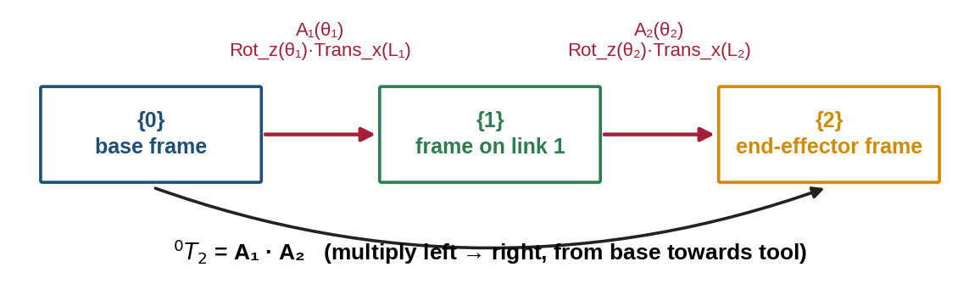
Figure 4.3: Transformation chain for the 2-DOF arm: ⁰T₂ = A₁ · A₂.

4.4 Building and Multiplying the Matrices
Put α = 0 and d = 0 into the DH matrix (3.1). Because cos 0 = 1 and sin 0 = 0, it simplifies to a planar rotation plus a shift along the link. Writing cᵢ = cos θᵢ and sᵢ = sin θᵢ:

A₁ = |  | c₁ | −s₁ | 0 | L₁c₁ |  |  | A₂ = |  | c₂ | −s₂ | 0 | L₂c₂
A₁ = |  | s₁ | c₁ | 0 | L₁s₁ |  |  | A₂ = |  | s₂ | c₂ | 0 | L₂s₂
A₁ = |  | 0 | 0 | 1 | 0 |  |  | A₂ = |  | 0 | 0 | 1 | 0
A₁ = |  | 0 | 0 | 0 | 1 |  |  | A₂ = |  | 0 | 0 | 0 | 1

Multiply row by column. For example, entry (1,1) = c₁c₂ − s₁s₂, which the identity cos(A + B) = cos A cos B − sin A sin B turns into c₁₂ = cos(θ₁ + θ₂). Entry (1,4) = c₁(L₂c₂) − s₁(L₂s₂) + L₁c₁ = L₁c₁ + L₂c₁₂. Doing the same for every entry gives:

⁰T₂ = A₁A₂ = |  | c₁₂ | −s₁₂ | 0 | L₁c₁ + L₂c₁₂
⁰T₂ = A₁A₂ = |  | s₁₂ | c₁₂ | 0 | L₁s₁ + L₂s₁₂
⁰T₂ = A₁A₂ = |  | 0 | 0 | 1 | 0
⁰T₂ = A₁A₂ = |  | 0 | 0 | 0 | 1

The last column is exactly equations (4.1) and (4.2), and the rotation block is a rotation by θ₁ + θ₂, matching (4.3). The geometric method and the DH method agree — this cross-check is the best way to gain confidence in a DH model.

4.5 Numerical Example and Verification
Given: L₁ = 10 cm, L₂ = 7 cm, θ₁ = 30°, θ₂ = 45°. Method 1 (equations): θ₁ + θ₂ = 75°; cos 75° = 0.2588, sin 75° = 0.9659. x = 10 × 0.8660 + 7 × 0.2588 = 8.660 + 1.812 = 10.472 cm; y = 10 × 0.5000 + 7 × 0.9659 = 5.000 + 6.761 = 11.761 cm; φ = 75°.
Method 2 (DH matrices): with the numbers substituted,

A₁ = |  | 0.8660 | −0.5000 | 0 | 8.660 |  |  | A₂ = |  | 0.7071 | −0.7071 | 0 | 4.950
A₁ = |  | 0.5000 | 0.8660 | 0 | 5.000 |  |  | A₂ = |  | 0.7071 | 0.7071 | 0 | 4.950
A₁ = |  | 0 | 0 | 1 | 0 |  |  | A₂ = |  | 0 | 0 | 1 | 0
A₁ = |  | 0 | 0 | 0 | 1 |  |  | A₂ = |  | 0 | 0 | 0 | 1

⁰T₂ = |  | 0.2588 | −0.9659 | 0 | 10.472
⁰T₂ = |  | 0.9659 | 0.2588 | 0 | 11.761
⁰T₂ = |  | 0 | 0 | 1 | 0
⁰T₂ = |  | 0 | 0 | 0 | 1

For example, entry (1,4) = 0.8660 × 4.950 + (−0.5000) × 4.950 + 0 × 0 + 8.660 × 1 = 4.287 − 2.475 + 8.660 = 10.472. Both methods give (10.472, 11.761) cm, and the first column (cos 75°, sin 75°) confirms φ = 75°. Sanity check: the distance from the base, √(10.472² + 11.761²) = 15.75 cm, lies between |L₁ − L₂| = 3 cm and L₁ + L₂ = 17 cm.

4.6 How Each Joint Angle Moves the End Effector
Figure 4.4 shows the effect of each joint separately. Changing θ₁ swings the whole arm around the base like the hand of a clock: the tip moves on a circle, and its distance from the base does not change. Changing θ₂ bends the elbow: the tip moves on a smaller circle around the elbow, and its distance from the base changes — the arm becomes longer when straight (θ₂ = 0) and shorter when folded (θ₂ = ±180°).
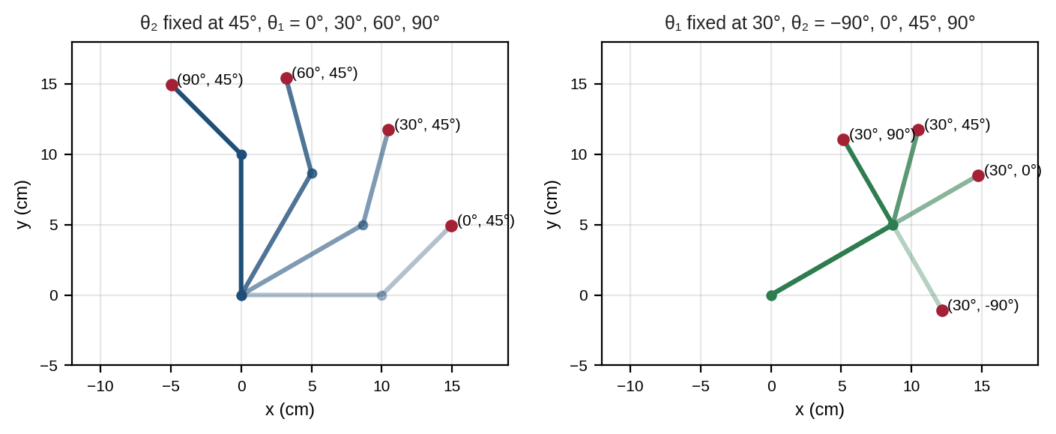
Figure 4.4: Effect of changing θ₁ alone (left) and θ₂ alone (right) on the arm pose and end-effector position.
θ₁ | θ₂ | x (cm) | y (cm) | φ | What you see
0° | 0° | 17.000 | 0.000 | 0° | Arm fully stretched along x₀ (maximum reach)
90° | 0° | 0.000 | 17.000 | 90° | Fully stretched along y₀
30° | 45° | 10.472 | 11.761 | 75° | Worked example of Section 4.5
45° | −90° | 12.021 | 2.121 | −45° | Elbow bent clockwise (negative θ₂)
60° | 60° | 1.500 | 14.722 | 120° | Elbow bent counter-clockwise
120° | −30° | −5.000 | 15.660 | 90° | Tip in the second quadrant (negative x)
0° | 180° | 3.000 | 0.000 | 180° | Fully folded (minimum reach)

These values were computed with the Lab 2 program and checked against equations (4.1)–(4.2).

4.7 Workspace
If both joints can turn a full 360°, the tip can reach every point whose distance r from the base satisfies |L₁ − L₂| ≤ r ≤ L₁ + L₂. For our arm that is a ring (annulus) between 3 cm and 17 cm (Figure 4.5). Points on the outer edge are reached only with the arm straight, and points on the inner edge only with it fully folded; at these edges the arm is in a singular configuration and loses the ability to move the tip in some directions. Real servos turn only about 180°, which cuts the ring into a smaller region (see Lab 3).
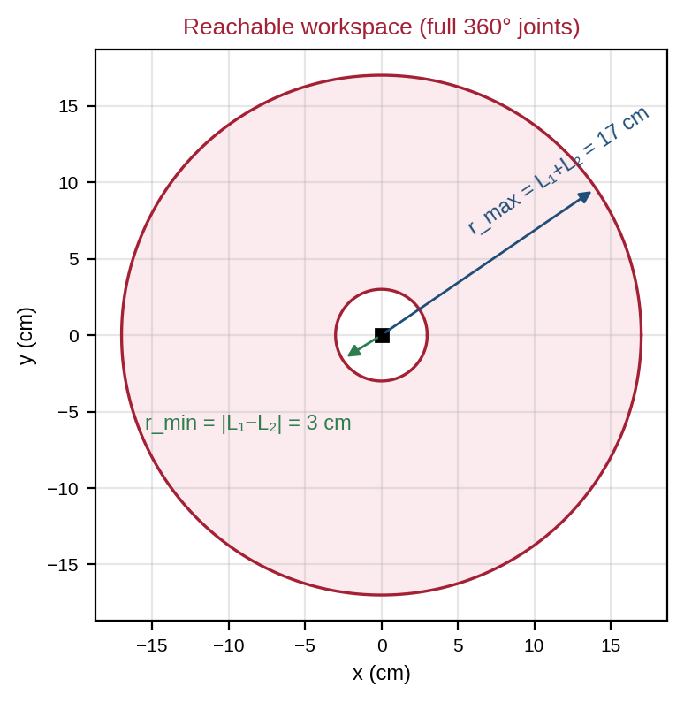
Figure 4.5: Workspace of the 2-DOF arm with L₁ = 10 cm and L₂ = 7 cm and unlimited joint rotation.

4.8 The Forward-Kinematics Workflow
Figure 4.6 summarises the method you can apply to any serial robot. Steps 1–3 are done on paper, steps 4–5 are routine calculation (ideal for a computer) and step 6 must never be skipped.
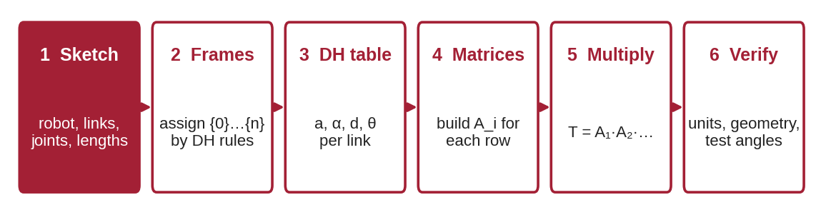
Figure 4.6: Six-step forward-kinematics workflow from robot sketch to verified result.
A first look at inverse kinematics
For this arm, the elbow angle can be found from the target distance using the law of cosines: cos θ₂ = (x² + y² − L₁² − L₂²) ÷ (2L₁L₂). Two values of θ₂ (positive and negative) give the same cos θ₂ — these are the "elbow-down" and "elbow-up" solutions. If the right-hand side is greater than 1 or less than −1, the point is outside the workspace. A full treatment follows in the next module.

5. Practical Lab Exercises
The three labs below turn the theory of Sections 2–4 into working tools. All three can be completed with only a web browser using Google Colab (free, with NumPy and Matplotlib pre-installed). Each lab lists its time, prerequisites, exact steps and the evidence to record, and ends with a model solution so that learners can check their work and instructors can mark consistently. Lab 3 also has an optional hardware extension that uses two servos.
Lab | Title | Section | Time | Hardware
1 | Translation and rotation transformations in Python | 2 | 2 h | None
2 | DH table and forward-kinematics calculator | 3, 4 | 2.5 h | None
3 | Visualise and verify a 2-DOF planar arm | 4 | 3 h (+1 h optional) | Optional: Uno + 2 servos

Software Setup (once, before Lab 1)
- Option A — no installation: open colab.research.google.com, sign in with a Google account and choose File → New notebook. Paste each program into a code cell and press Shift + Enter.
- Option B — own computer: install Python 3.10 or newer from python.org, then open a terminal and run pip install numpy matplotlib. Save each program as a .py file and run it with python filename.py.
- Option C — spreadsheet only: LibreOffice Calc, Google Sheets or Excel can complete Lab 2 using the formulas given there.
- Check the setup by running import numpy, matplotlib; print(numpy.__version__) — a version number such as 1.26 or 2.x must appear.
Remember
Python’s np.cos() and np.sin() expect radians. Every program in this module converts degrees with np.radians() before calling them.

Lab Exercise 1: Translation and Rotation Transformations in Python
Estimated time | Prerequisites
2 hours | Section 2; basic Python (variables, functions); setup completed

Objective
To build 2D homogeneous translation and rotation matrices in Python, apply them to points and shapes, and prove by experiment that the order of matrix multiplication changes the result.
Components Required
- PC or laptop with a browser (no robot hardware needed)
- Graph paper, ruler and protractor for hand checks
Software Required
- Python 3.10+ with NumPy and Matplotlib, or Google Colab
Working Principle
A 3 × 3 homogeneous matrix holds a 2D rotation (top-left 2 × 2 block) and a translation (right column). A point (x, y) is written as (x, y, 1) so that one multiplication applies both. The @ operator in NumPy performs matrix multiplication. Applying trans(2, 1) @ rot(90) and rot(90) @ trans(2, 1) to the same unit square shows two different final positions, demonstrating Section 2.5.
Model Setup
Draw frame {0} on graph paper with 1 cm squares. Mark the point P = (1, 0) and a unit square with corners (0, 0), (1, 0), (1, 1), (0, 1). You will predict the results by hand before running the code.
Procedure
- By hand, predict where P = (1, 0) lands after (a) translating by (2, 1) then rotating 90° about the new z-axis, and (b) rotating 90° then translating by (2, 1) along the new axes. Write both predictions down.
- Open a new Colab notebook (or .py file), enter the program below and run it.
- Copy the two printed matrices and the two transformed points into the observation table.
- Compare the plot with your hand predictions on graph paper.
- Change rot(90) to rot(30) in both lines and record the new coordinates of P.
- Add the line R = rot(30)[:2, :2]; print(R @ R.T) and record what is printed (it tests R⁻¹ = Rᵀ).
Program Code
# Lab 1: 2D homogeneous translation and rotation (numpy + matplotlib)
import numpy as np
import matplotlib.pyplot as plt

def trans(tx, ty):
"""3x3 homogeneous translation by (tx, ty)."""
return np.array([[1, 0, tx],
[0, 1, ty],
[0, 0, 1]], dtype=float)

def rot(theta_deg):
"""3x3 homogeneous rotation about z by theta (degrees in, radians inside)."""
t = np.radians(theta_deg)
c, s = np.cos(t), np.sin(t)
return np.array([[c, -s, 0],
[s, c, 0],
[0, 0, 1]])

np.set_printoptions(precision=3, suppress=True)
P = np.array([1.0, 0.0, 1.0]) # point (1, 0) in homogeneous form

T_tr = trans(2, 1) @ rot(90) # translate, then rotate (about the new z)
T_rt = rot(90) @ trans(2, 1) # rotate, then translate (along the new axes)
print("Trans(2,1)*Rot(90):\n", T_tr)
print("Rot(90)*Trans(2,1):\n", T_rt)
print("P after T_tr:", (T_tr @ P)[:2])
print("P after T_rt:", (T_rt @ P)[:2])

# Visualise a unit square under each transform
sq = np.array([[0, 1, 1, 0, 0],
[0, 0, 1, 1, 0],
[1, 1, 1, 1, 1]], dtype=float)
plt.figure(figsize=(5, 5))
plt.plot(sq[0], sq[1], "k-", lw=2, label="original")
for T, name, col in [(T_tr, "Trans·Rot", "tab:green"), (T_rt, "Rot·Trans", "tab:red")]:
q = T @ sq
plt.plot(q[0], q[1], "-", color=col, lw=2, label=name)
plt.axhline(0, color="grey", lw=0.5); plt.axvline(0, color="grey", lw=0.5)
plt.gca().set_aspect("equal"); plt.grid(alpha=0.3); plt.legend()
plt.xlabel("x"); plt.ylabel("y"); plt.title("Order of transformations matters")
plt.savefig("lab1_output.png", dpi=150, bbox_inches="tight")
plt.show()

Expected Output
The console shows two different 3 × 3 matrices. After Trans·Rot, P is at (2, 2); after Rot·Trans, P is at (−1, 3). The plot (Figure 5.1) shows the original square in black and two squares in different places, confirming that the multiplication order matters.
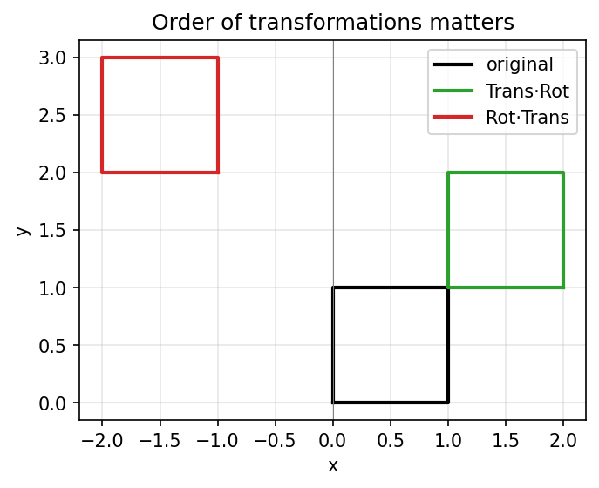
Figure 5.1: Output of Lab 1: the same two operations in different orders place the square in different positions.
Observation
Record what you see while running the experiment. Fill in the table below and attach screenshots of the program output and your hand sketch.
# | What to observe | Your observation
1 | Printed matrix Trans(2,1)·Rot(90)
2 | Printed matrix Rot(90)·Trans(2,1)
3 | Coordinates of P after each product (90°)
4 | Coordinates of P after each product (30°)
5 | Result of R @ R.T for 30°

Model Solution
# | Correct result | Explanation
1 | [[0, −1, 2], [1, 0, 1], [0, 0, 1]] | Rotation block of 90°; translation column (2, 1) unchanged
2 | [[0, −1, −1], [1, 0, 2], [0, 0, 1]] | Translation (2, 1) is itself rotated by 90° → (−1, 2)
3 | Trans·Rot: (2, 2) Rot·Trans: (−1, 3) | (1, 0) → rotated (0, 1) → +(2, 1) = (2, 2); and (1, 0) + (2, 1) = (3, 1) → rotated (−1, 3)
4 | Trans·Rot: (2.866, 1.500) Rot·Trans: (2.098, 2.366) | cos 30° = 0.866, sin 30° = 0.5; second: rotate (3, 1) by 30°
5 | [[1, 0], [0, 1]] (identity) | Confirms the rotation matrix is orthonormal: R⁻¹ = Rᵀ

Precautions
- Always convert degrees to radians before calling np.cos or np.sin.
- Use @ (matrix product), not * (element-by-element product).
Applications
The same matrices move objects in computer graphics and games, place a camera relative to a robot, and convert a sensor reading from the sensor’s frame into the robot’s base frame.
Conclusion
Homogeneous matrices combine rotation and translation in one operation, and the order of multiplication changes the result. Evidence to record: hand predictions, console output, plot screenshot and completed tables.

Lab Exercise 2: DH Table and Forward-Kinematics Calculator
Estimated time | Prerequisites
2.5 hours | Sections 3 and 4.1–4.5; Lab 1 completed

Objective
To assign DH frames to the 2-DOF planar arm, build its DH table, and implement a forward-kinematics calculator in Python (and optionally in a spreadsheet) that is verified against the geometric equations (4.1)–(4.2).
Components Required
- PC or laptop
- Printed copy of Figure 4.1 or a hand sketch of the arm on graph paper
Software Required
- Python 3.10+ with NumPy, or Google Colab
- Optional: LibreOffice Calc, Google Sheets or Excel
Working Principle
The function dh(a, alpha, d, theta) returns the standard DH matrix (3.1). The 2-DOF arm has DH rows (L₁, 0, 0, θ₁) and (L₂, 0, 0, θ₂), so A1 @ A2 gives ⁰T₂. The program also computes x and y with the geometric formulas and uses assert to stop with an error if the two methods ever disagree. The orientation φ is recovered from the rotation block with atan2(T[1,0], T[0,0]).
Model Setup
On graph paper, draw the arm at θ₁ = 30°, θ₂ = 45° with L₁ = 10 cm and L₂ = 7 cm. Draw frames {0}, {1} and {2} using the procedure of Section 3.3 and label every axis.
Procedure
- Complete the DH table for the arm on paper (columns: link, a, α, d, θ) and mark the joint variables with *.
- Enter and run the program below. Copy the printed ⁰T₂ for (30°, 45°).
- Check that each row of the printed table has identical DH and geometric columns.
- Add two angle pairs of your own choice to the list and run again.
- Spreadsheet option: in cell A1 type θ₁ (degrees) and in B1 θ₂; in C1 enter =10*COS(RADIANS(A1))+7*COS(RADIANS(A1+B1)) and in D1 =10*SIN(RADIANS(A1))+7*SIN(RADIANS(A1+B1)). Compare with Python.
- Deliberately delete np.radians from fk_dh and run again. Record what happens and why.
Program Code
# Lab 2: Standard DH forward kinematics of a 2-DOF planar arm
import numpy as np

def dh(a, alpha, d, theta):
"""Standard DH link matrix A = Rz(theta) Tz(d) Tx(a) Rx(alpha). Angles in radians."""
ct, st = np.cos(theta), np.sin(theta)
ca, sa = np.cos(alpha), np.sin(alpha)
return np.array([[ct, -st*ca, st*sa, a*ct],
[st, ct*ca, -ct*sa, a*st],
[0, sa, ca, d],
[0, 0, 0, 1]])

L1, L2 = 10.0, 7.0 # link lengths in cm

def fk_dh(t1_deg, t2_deg):
t1, t2 = np.radians([t1_deg, t2_deg])
# DH table rows: (a, alpha, d, theta)
A1 = dh(L1, 0.0, 0.0, t1)
A2 = dh(L2, 0.0, 0.0, t2)
return A1 @ A2 # base -> end effector

def fk_geo(t1_deg, t2_deg):
t1, t2 = np.radians([t1_deg, t2_deg])
x = L1*np.cos(t1) + L2*np.cos(t1 + t2)
y = L1*np.sin(t1) + L2*np.sin(t1 + t2)
return x, y

np.set_printoptions(precision=4, suppress=True)
print("T for theta1=30, theta2=45:\n", fk_dh(30, 45))
print(f"{'th1':>5} {'th2':>5} | {'x_DH':>8} {'y_DH':>8} | {'x_geo':>8} {'y_geo':>8} | {'phi':>6}")
for t1, t2 in [(0, 0), (90, 0), (30, 45), (45, -90), (60, 60), (120, -30), (0, 180)]:
T = fk_dh(t1, t2)
xg, yg = fk_geo(t1, t2)
phi = np.degrees(np.arctan2(T[1, 0], T[0, 0]))
assert np.allclose(T[:2, 3], [xg, yg]) # both methods must agree
print(f"{t1:5d} {t2:5d} | {T[0,3]:8.3f} {T[1,3]:8.3f} | {xg:8.3f} {yg:8.3f} | {phi:6.1f}")

Expected Output
The program prints ⁰T₂ for (30°, 45°) — matching Section 4.5 — followed by a table in which the DH and geometric results are identical. If they ever differ, assert stops the program with an AssertionError, signalling a bug.
T for theta1=30, theta2=45:
[[ 0.2588 -0.9659 0. 10.472 ]
[ 0.9659 0.2588 0. 11.7615]
[ 0. 0. 1. 0. ]
[ 0. 0. 0. 1. ]]
th1 th2 | x_DH y_DH | x_geo y_geo | phi
0 0 | 17.000 0.000 | 17.000 0.000 | 0.0
90 0 | 0.000 17.000 | 0.000 17.000 | 90.0
30 45 | 10.472 11.761 | 10.472 11.761 | 75.0
45 -90 | 12.021 2.121 | 12.021 2.121 | -45.0
60 60 | 1.500 14.722 | 1.500 14.722 | 120.0
120 -30 | -5.000 15.660 | -5.000 15.660 | 90.0
0 180 | 3.000 0.000 | 3.000 0.000 | 180.0

Observation
Record what you see while running the experiment. Fill in the table below and attach a photo of your frame sketch and screenshots of the output.
# | What to observe | Your observation
1 | Your DH table (all rows)
2 | Printed ⁰T₂ for (30°, 45°)
3 | Largest difference between DH and geometric x, y
4 | x, y for your two extra angle pairs
5 | Result when np.radians is removed

Model Solution
# | Correct result | Explanation
1 | Row 1: a = 10 cm, α = 0, d = 0, θ = θ₁*; Row 2: a = 7 cm, α = 0, d = 0, θ = θ₂* | Parallel z-axes → α = 0; common normals lie along the links
2 | Last column (10.472, 11.761, 0, 1); rotation block = 75° rotation | Matches Section 4.5 exactly
3 | 0 (to printed precision) | Both methods are the same mathematics; assert passes
4 | Depends on choice; e.g. (90°, 90°) → (−7.000, 10.000) | x = 10·0 + 7·cos 180° = −7; y = 10·1 + 7·sin 180° = 10
5 | (30, 45) gives x ≈ 7.995, y ≈ −12.595 — nonsense | 30 and 75 are treated as radians (≈ 1719° and 4297°)

Precautions
- Keep all lengths in one unit (cm here).
- Do not copy a modified-DH matrix from the internet into dh() — the table in this lab is standard DH.
Applications
The same dh() function, given the right table, computes the kinematics of SCARA robots, 6-axis industrial arms and humanoid limbs — only the table changes.
Conclusion
A correctly built DH table plus matrix multiplication reproduces the geometric solution exactly, giving a general and reusable FK method. Evidence to record: annotated frame sketch, DH table, code output and the radian-error test.

Lab Exercise 3: Visualise and Verify a 2-DOF Planar Arm
Estimated time | Prerequisites
3 hours (+1 hour for the optional servo build) | Labs 1–2; for hardware: Semester 1 servo lab (Uno, SG90, separate supply)

Objective
To plot the 2-DOF arm in several poses, map its workspace for realistic servo limits, and compare calculated end-effector positions with positions measured on a physical model (paper or servo arm).
Components Required
- Essential: cardboard links (10 cm and 7 cm between pivot holes), two split pins, graph paper, protractor, ruler
- Optional: Arduino Uno R3, 2 × SG90 servos, 4 × AA battery pack (6 V), jumper wires, felt pen as end effector
Software Required
- Python with NumPy and Matplotlib, or Google Colab
- Optional: Arduino IDE 2.x (Servo library is built in) or the Wokwi simulator
Working Principle
The program evaluates equations (4.1)–(4.2) for five test poses, draws each arm and prints the tip coordinates. It then sweeps θ₁ from 0° to 180° and θ₂ from −90° to +90° — the ranges an SG90 can actually reach in this build — and plots every reachable tip position. A physical model placed with its shoulder on the origin of the graph paper lets you read the tip position directly and compare it with the calculation.
Circuit / Mechanical Setup
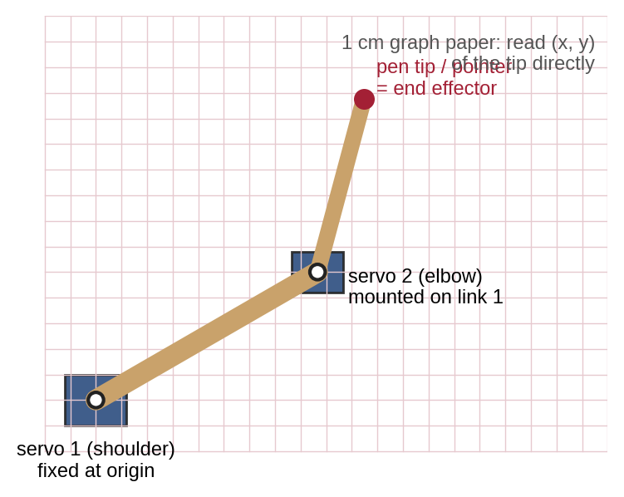
Figure 5.2: Physical setup: shoulder pivot at the graph-paper origin, elbow pivot at the end of link 1 and the pen tip as end effector.
Wiring (optional servo arm): shoulder servo signal → Uno D9, elbow servo signal → Uno D10, both red wires → battery pack + (6 V), both brown wires → battery pack − and Uno GND (common ground). Never power the servos from the Uno 5 V pin.
Procedure
- Run the program below and save the plot. Copy the five calculated (x, y) pairs into the comparison table.
- Paper model: pin the shoulder on the origin. For each pose, set θ₁ with the protractor from the +x axis and θ₂ from the line of link 1. Read the tip (x, y) from the grid to the nearest 0.1 cm.
- Servo model (optional): upload the sketch below, open the Serial Monitor at 115200 baud and type, for example, 30 45 and Enter. Calibrate OFFSET2 so that θ₂ = 0 makes the arm straight. Read the pen-tip position for each pose.
- Calculate the error for each pose: e = √((x_meas − x_calc)² + (y_meas − y_calc)²).
- Measure your real link lengths between pivot centres, update L1 and L2 in the code and repeat. Note whether the error falls.
Program Code
Python visualiser (no hardware):
# Lab 3: 2-DOF arm visualiser + workspace + calculated targets for hardware check
import numpy as np
import matplotlib.pyplot as plt

L1, L2 = 10.0, 7.0 # cm (measure YOUR arm and edit)

def fk(t1_deg, t2_deg):
t1, t2 = np.radians(t1_deg), np.radians(t2_deg)
j = np.array([L1*np.cos(t1), L1*np.sin(t1)])
e = j + L2*np.array([np.cos(t1 + t2), np.sin(t1 + t2)])
return j, e

poses = [(0, 0), (30, 45), (60, 60), (90, -90), (120, 30)]
fig, (ax1, ax2) = plt.subplots(1, 2, figsize=(10, 4.6))
for t1, t2 in poses:
j, e = fk(t1, t2)
ax1.plot([0, j[0], e[0]], [0, j[1], e[1]], "-o", lw=2)
ax1.annotate(f"({t1},{t2})\n({e[0]:.1f}, {e[1]:.1f})", e, fontsize=8,
textcoords="offset points", xytext=(4, 4))
print(f"theta1={t1:4d} theta2={t2:4d} -> x={e[0]:7.2f} cm y={e[1]:7.2f} cm")
ax1.set_title("Arm poses (labels: angles, tip position)")

# Workspace: theta1 0..180, theta2 -90..90 (the servo ranges used in this lab)
T1, T2 = np.meshgrid(np.arange(0, 181, 3), np.arange(-90, 91, 3))
X = L1*np.cos(np.radians(T1)) + L2*np.cos(np.radians(T1 + T2))
Y = L1*np.sin(np.radians(T1)) + L2*np.sin(np.radians(T1 + T2))
ax2.scatter(X, Y, s=2, c=T2, cmap="viridis")
ax2.set_title("Workspace: theta1 0..180, theta2 -90..90")
for ax in (ax1, ax2):
ax.set_aspect("equal"); ax.grid(alpha=0.3)
ax.set_xlabel("x (cm)"); ax.set_ylabel("y (cm)")
ax.set_xlim(-18, 18); ax.set_ylim(-9, 18)
plt.tight_layout(); plt.savefig("lab3_output.png", dpi=150); plt.show()

Optional Arduino sketch (servo arm):
// Optional hardware: 2-servo planar arm. Type "30 45" + Enter in the Serial Monitor.
#include <Servo.h>
Servo s1, s2; // s1 = shoulder (pin 9), s2 = elbow (pin 10)
const int OFFSET1 = 0, OFFSET2 = 90; // calibrate so that arm angles map to servo angles

void setup() {
Serial.begin(115200);
s1.attach(9); s2.attach(10);
s1.write(0 + OFFSET1); s2.write(0 + OFFSET2); // home: arm straight along +x
Serial.println(F("Enter theta1 theta2 in degrees (theta1 0..180, theta2 -90..90)"));
}

void loop() {
if (Serial.available()) {
int t1 = Serial.parseInt();
int t2 = Serial.parseInt();
while (Serial.available()) Serial.read(); // discard the rest of the line
int c1 = constrain(t1 + OFFSET1, 0, 180);
int c2 = constrain(t2 + OFFSET2, 0, 180);
s1.write(c1); s2.write(c2);
float a = radians(t1), b = radians(t2);
float x = 10.0 * cos(a) + 7.0 * cos(a + b); // L1 = 10 cm, L2 = 7 cm
float y = 10.0 * sin(a) + 7.0 * sin(a + b);
Serial.print(F("theta1=")); Serial.print(t1); Serial.print(F(" theta2=")); Serial.print(t2);
Serial.print(F(" predicted x=")); Serial.print(x, 2); Serial.print(F(" cm y=")); Serial.print(y, 2); Serial.println(F(" cm"));
}
}

Expected Output
The console prints the calculated tip positions listed in the model solution. The left plot shows the five poses; the right plot shows a curved, crescent-shaped workspace instead of the full ring of Figure 4.5, because the servos cannot rotate all the way round (Figure 5.3).
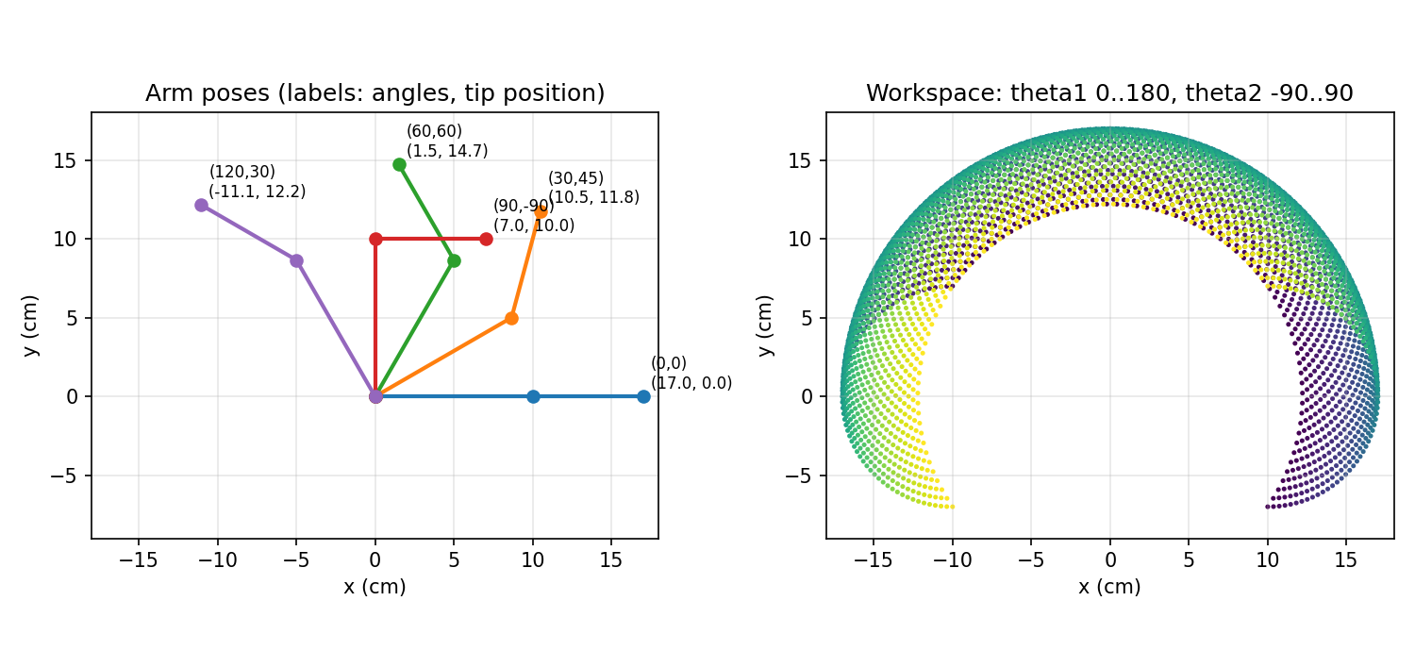
Figure 5.3: Output of Lab 3: five test poses with tip coordinates (left) and the reachable workspace for servo-limited joints (right).
Observation
Record what you measure while running the experiment. Fill in the table and attach the plot and a photo of the model in at least two poses.
θ₁ | θ₂ | x calc (cm) | y calc (cm) | x meas (cm) | y meas (cm) | Error e (cm)
0° | 0°
30° | 45°
60° | 60°
90° | −90°
120° | 30°

Model Solution
The calculated columns must match the values below (L₁ = 10 cm, L₂ = 7 cm). Measured values come from your own model and are not given here; with careful cardboard construction they are normally within a few millimetres of the calculation, and errors well above 1 cm indicate a set-up problem.
θ₁ | θ₂ | x calc (cm) | y calc (cm) | Hand check
0° | 0° | 17.00 | 0.00 | Straight along x: 10 + 7
30° | 45° | 10.47 | 11.76 | Section 4.5
60° | 60° | 1.50 | 14.72 | 10(0.5) + 7(−0.5) = 1.5; 10(0.866) + 7(0.866) = 14.72
90° | −90° | 7.00 | 10.00 | Link 1 straight up, link 2 horizontal to the right
120° | 30° | −11.06 | 12.16 | 10(−0.5) + 7(−0.866); 10(0.866) + 7(0.5)

Typical sources of error: pivot holes not exactly 10 cm and 7 cm apart; play (looseness) in split pins or servo horns; servo zero not aligned (fix with OFFSET values); reading the protractor from the wrong reference line for θ₂.
Precautions
- Keep fingers clear of moving servos; disconnect the battery before re-fitting horns.
- Stay inside the workspace limits — sending angles beyond 0–180° makes the sketch clamp them, so the arm will not reach the calculated point.
Applications
Plotting robots, camera pan-tilt units and simple pick-and-place machines use exactly this FK model; comparing calculated and measured positions is how real robots are calibrated.
Conclusion
The FK equations predict the real tip position, and the remaining error reveals mechanical imperfections. Evidence to record: plot, completed comparison table, photos and a short paragraph explaining the largest error.

6. Integrated Mini-Project: 2-DOF Forward-Kinematics Visualiser

6.1 Problem Statement
A school robotics club wants a simple tool to teach forward kinematics. Build an interactive visualiser in which the user moves two sliders (θ₁ and θ₂) and immediately sees the arm, the end-effector coordinates, the orientation φ and the workspace limits. If the optional servo arm from Lab 3 is available, the same angles should be sent to it so that the screen and the real arm can be compared.

6.2 System Design
Block | Function | Built in
Input | Two Matplotlib sliders, −180° to +180° | This project
FK engine | Equations (4.1)–(4.3) (or the dh() function of Lab 2) | Labs 2, 3
Display | Arm drawing, tip trail, live x, y, φ, workspace circles | Lab 3
Optional output | Serial command “θ₁ θ₂” to the Uno servo sketch | Lab 3 extension

6.3 Materials, Software and Workflow
Materials and software are the same as for Lab 3. Sliders need an interactive plotting window, so run this program on your own computer with python miniproject_slider.py (in Google Colab, sliders do not respond without extra widget set-up; use Lab 3 there instead). Suggested workflow: (1) copy the FK function from Lab 2; (2) draw a static arm; (3) add the sliders and the update() function; (4) add the live text and workspace circles; (5) run the test cases; (6) write a one-page report with screenshots.
# Mini-project: interactive 2-DOF forward-kinematics visualiser (sliders)
import numpy as np
import matplotlib.pyplot as plt
from matplotlib.widgets import Slider

L1, L2 = 10.0, 7.0

def fk(t1, t2): # degrees in
a, b = np.radians(t1), np.radians(t2)
j = (L1*np.cos(a), L1*np.sin(a))
e = (j[0] + L2*np.cos(a + b), j[1] + L2*np.sin(a + b))
return j, e

fig, ax = plt.subplots(figsize=(6, 6))
plt.subplots_adjust(bottom=0.25)
ax.set_aspect("equal"); ax.grid(alpha=0.3)
ax.set_xlim(-18, 18); ax.set_ylim(-18, 18)
ax.set_xlabel("x (cm)"); ax.set_ylabel("y (cm)")
t = np.linspace(0, 2*np.pi, 200)
ax.plot((L1+L2)*np.cos(t), (L1+L2)*np.sin(t), "r--", lw=0.8) # max reach
ax.plot(abs(L1-L2)*np.cos(t), abs(L1-L2)*np.sin(t), "r--", lw=0.8)
arm, = ax.plot([], [], "-o", lw=4, ms=8, color="tab:blue")
trail, = ax.plot([], [], ".", ms=2, color="tab:orange")
label = ax.text(-17, 17, "", fontsize=10, va="top")
s1 = Slider(plt.axes([0.15, 0.12, 0.7, 0.03]), "theta1 (deg)", -180, 180, valinit=30)
s2 = Slider(plt.axes([0.15, 0.06, 0.7, 0.03]), "theta2 (deg)", -180, 180, valinit=45)
xs, ys = [], []

def update(_=None):
j, e = fk(s1.val, s2.val)
arm.set_data([0, j[0], e[0]], [0, j[1], e[1]])
xs.append(e[0]); ys.append(e[1]); trail.set_data(xs, ys)
label.set_text(f"x = {e[0]:6.2f} cm\ny = {e[1]:6.2f} cm\nphi = {s1.val + s2.val:6.1f} deg")
fig.canvas.draw_idle()

s1.on_changed(update); s2.on_changed(update); update()
plt.savefig("miniproject_output.png", dpi=150, bbox_inches="tight")
plt.show()

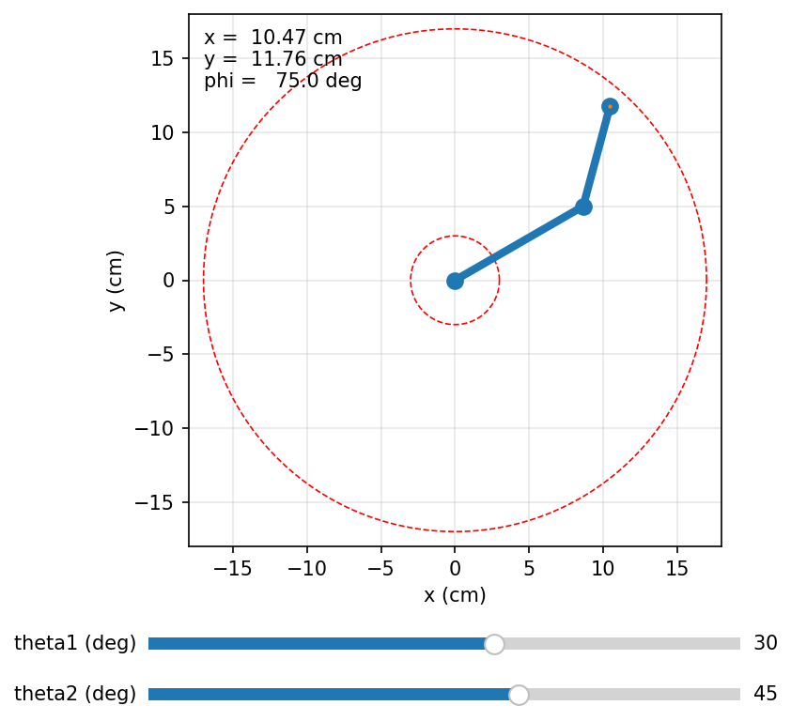
Figure 6.1: Mini-project visualiser at θ₁ = 30°, θ₂ = 45°, showing the arm, live coordinates and the workspace boundaries.

6.4 Test Cases
Test | Slider setting (θ₁, θ₂) | Expected result
TC1 | (0°, 0°) | x = 17.00, y = 0.00, φ = 0°; tip on the outer circle
TC2 | (30°, 45°) | x = 10.47, y = 11.76, φ = 75°
TC3 | (90°, 0°) | x = 0.00, y = 17.00, φ = 90°
TC4 | (0°, 180°) | x = 3.00, y = 0.00; tip on the inner circle (folded)
TC5 | (45°, −90°) then (45°, +90°) | (12.02, 2.12) then (2.12, 12.02): mirror images about the 45° line
TC6 | Sweep θ₁ with θ₂ = 0° | Trail is a circle of radius 17 cm
TC7 | Sweep θ₂ with θ₁ = 0° | Trail is a circle of radius 7 cm centred on (10, 0)

6.5 Expected Results, Limitations and Extensions
All seven tests should pass to two decimal places. Limitations: the model assumes perfectly rigid links, exact link lengths and ideal joints; it ignores joint limits, link thickness and collisions; and it shows position only, not speed or force. Possible extensions: add joint-limit warnings, add the inverse-kinematics formula from Section 4.8 so that clicking a point moves the arm there, add a third link (3-DOF) using the dh() function, or stream the slider angles to the servo arm over USB serial.

7. Troubleshooting and Common Mistakes
Most kinematics errors produce answers that look reasonable but are wrong. The table lists the classic mistakes, how to recognise them and how to fix them. When in doubt, always test the zero pose (all angles 0) and one simple pose such as θ₁ = 90°, θ₂ = 0°, where the answer can be found without a calculator.
Mistake | Symptom | Fix
Degrees vs radians | Wild or negative coordinates; e.g. (30°, 45°) gives (7.99, −12.59) | Convert with np.radians() / RADIANS(); set the calculator to DEG for hand work
Incorrect frame assignment | Zero pose of the model does not match the sketch | Re-check: z₍ᵢ₋₁₎ on joint i; xᵢ along the common normal
Inconsistent DH convention | Formula from one book, table from another; results rotated or shifted | State the convention at the top of every table; use standard DH throughout
Wrong multiplication order | A₂·A₁ instead of A₁·A₂; tip in the wrong place except at special angles | Multiply from base to tool: ⁰Tₙ = A₁A₂…Aₙ
Incorrect link-length units | Answers 10× or 100× too big or small | Write the unit next to every length; convert once at the start
Sign errors | Mirror-image results (tip below instead of above) | Use the right-hand rule; counter-clockwise is positive
Misreading θ₂ | Measuring θ₂ from the x₀-axis instead of from link 1 | θ₂ is relative; the absolute angle of link 2 is θ₁ + θ₂
Using * instead of @ in NumPy | Matrix full of strange products; bottom row not (0 0 0 1) | Use @ or np.matmul for matrix products
Target outside the workspace | IK gives cos θ₂ > 1 or arm cannot reach | Check |L₁ − L₂| ≤ r ≤ L₁ + L₂ first
Servo offset not calibrated | Constant angular error in all hardware poses | Adjust OFFSET values so the zero pose is straight along +x

8. Assessment and Revision

8.1 Formula Sheet
Quantity | Formula | Units / notes
2D rotation of a point | x′ = x cos θ − y sin θ; y′ = x sin θ + y cos θ | θ positive counter-clockwise
Homogeneous point | (x, y, z) → (x, y, z, 1) | Last entry always 1
Chaining frames | ⁰T₂ = ⁰T₁ · ¹T₂ | Inner indices cancel
Inverse transform | T⁻¹ = [Rᵀ −Rᵀp; 0 0 0 1] | R⁻¹ = Rᵀ
Standard DH link matrix | Aᵢ = Rot_z(θᵢ) Trans_z(dᵢ) Trans_x(aᵢ) Rot_x(αᵢ) | Equation (3.1)
Forward kinematics | ⁰Tₙ = A₁ A₂ … Aₙ | Base → tool
2-DOF position | x = L₁c₁ + L₂c₁₂; y = L₁s₁ + L₂s₁₂ | c₁₂ = cos(θ₁ + θ₂)
2-DOF orientation | φ = θ₁ + θ₂ | degrees or radians
2-DOF workspace | |L₁ − L₂| ≤ √(x² + y²) ≤ L₁ + L₂ | Full-rotation joints
Degree ↔ radian | rad = deg × π/180; 1 rad ≈ 57.3° | Code uses radians

8.2 Short Conceptual Questions
- Define link, joint, end effector and degree of freedom. How many DOF does a desk lamp with two hinges have?
- What is the difference between forward and inverse kinematics? Which one always has exactly one answer?
- Why do robotics engineers add a "1" to the coordinates of a point?
- State three properties of a rotation matrix that can be used to check a calculation.
- Name the four DH parameters. Which two are constant for every link, and which one changes for a prismatic joint?
- In standard DH, along which joint’s axis is z₍ᵢ₋₁₎ placed?
- Why is the twist α equal to zero for both links of the 2-DOF planar arm?
- Explain why changing θ₁ alone never changes the distance of the tip from the base, but changing θ₂ does.
Answer key (brief): 1 — see Section 1.2; 2 DOF. 2 — FK: angles → pose, always one answer; IK: pose → angles. 3 — homogeneous coordinates let one matrix rotate and translate. 4 — unit-length columns, perpendicular columns, R⁻¹ = Rᵀ (det = +1). 5 — a, α, d, θ; a and α are fixed by link shape; d changes for a prismatic joint. 6 — joint i. 7 — all joint axes are parallel. 8 — θ₁ rotates the whole rigid arm about the base; θ₂ changes the angle between the links and hence the distance (law of cosines).

8.3 Numerical Problems with Worked Solutions
Problem 1. Rotate the point (3, 4) by 90° about z. Solution: cos 90° = 0, sin 90° = 1, so x′ = 3(0) − 4(1) = −4 and y′ = 3(1) + 4(0) = 3. Check: length √(16 + 9) = 5 before and after.
Problem 2. Frame {1} is rotated 90° about z and its origin is at (5, 2) in {0}. A point is at (1, 2) in {1}. Find it in {0}. Solution: rotate (1, 2) by 90° → (−2, 1); add the origin → (−2 + 5, 1 + 2) = (3, 3).
Problem 3. A 2-DOF arm has L₁ = 0.5 m and L₂ = 0.3 m. Find the tip pose for θ₁ = 60°, θ₂ = −30°. Solution: θ₁ + θ₂ = 30°. x = 0.5 cos 60° + 0.3 cos 30° = 0.250 + 0.260 = 0.510 m; y = 0.5 sin 60° + 0.3 sin 30° = 0.433 + 0.150 = 0.583 m; φ = 30°.
Problem 4. For L₁ = 10 cm and L₂ = 7 cm, which of these points can be reached with full-rotation joints: A (20, 0), B (2, 0), C (10, 10)? Solution: reachable band 3 ≤ r ≤ 17 cm. r_A = 20 → no; r_B = 2 → no (too close); r_C = √200 = 14.14 → yes.
Problem 5. For the cylindrical robot of Section 3.6 with d₁ = 20 cm, find the gripper position when θ₁ = 90°, d₂ = 5 cm and d₃ = 12 cm. Solution: x = d₃ cos 90° = 0, y = d₃ sin 90° = 12 cm, z = d₁ + d₂ = 25 cm.
Problem 6. A learner gets x = 7.99 cm, y = −12.59 cm for the arm of Section 4.5. What went wrong? Solution: 30 and 75 were treated as radians. With degrees converted correctly the answer is (10.47, 11.76) cm.

8.4 Practical Evaluation Checklist
# | The learner can… | Done
1 | Identify links, joints, DOF and the end effector on a real or pictured robot | ☐
2 | Write and apply translation and rotation HTMs; show order dependence (Lab 1) | ☐
3 | Assign DH frames and produce a correct DH table for the 2-DOF arm (Lab 2) | ☐
4 | Run the FK code and obtain matching DH and geometric results (Lab 2) | ☐
5 | Plot poses and workspace; compare calculation with measurement (Lab 3) | ☐
6 | Diagnose at least two deliberately introduced errors (radians, order, sign) | ☐
7 | Pass all mini-project test cases and explain one limitation | ☐

8.5 Simple Marking Rubric (20 marks)
Criterion | Excellent (4) | Good (3–2) | Needs work (1–0)
Concepts and terms | Uses all terms correctly with examples | Minor slips in terms | Confuses FK/IK or link/joint
Transformations | Correct matrices, order and checks | Small arithmetic errors | Wrong order or missing translation
DH modelling | Correct frames, table and convention stated | One sign or offset error | Frames or table largely incorrect
Implementation | Code runs, verified, outputs explained | Runs with minor issues | Does not run or unverified
Lab evidence and report | Complete tables, plots, error analysis | Some evidence missing | Little or no evidence

Glossary
Term | Meaning in simple words
Actuator | The motor or device that moves a joint (for example a servo motor).
Base frame {0} | The coordinate frame fixed to the robot’s base; all final answers are given in it.
Common normal | The shortest line joining two joint axes, meeting both at 90°. DH xᵢ lies along it.
Coordinate frame | An origin plus perpendicular x, y, z axes, used as a reference for measuring positions.
Degree of freedom (DOF) | One independent way a robot can move; for a serial arm, the number of joints.
Denavit–Hartenberg (DH) convention | Standard rules for placing link frames so that each link needs only four parameters.
DH parameters (a, α, d, θ) | Link length, link twist, link offset and joint angle that describe one link.
End effector | The tool at the end of the arm: gripper, suction cup, pen, torch.
Forward kinematics (FK) | Calculating the end-effector pose from known joint values.
Homogeneous coordinates | A point written with an extra 1, e.g. (x, y, z, 1), so one matrix can rotate and translate.
Homogeneous transformation matrix | A 4 × 4 (3D) or 3 × 3 (2D) matrix holding a rotation and a translation.
Identity matrix (I) | A matrix with 1s on the diagonal and 0s elsewhere; it changes nothing.
Inverse kinematics (IK) | Calculating the joint values needed to reach a desired pose; may have several or no solutions.
Joint | A connection between two links that allows motion.
Joint space | Description of the robot by its joint values (θ₁, θ₂, …).
Joint variable | The joint quantity a motor changes: θ for revolute, d for prismatic joints.
Kinematic chain | A series of links connected by joints, from base to end effector.
Kinematics | The study of motion (position, orientation, velocity) without considering forces.
Link | A rigid body of the robot, like a bone; the base is link 0.
Manipulator | A robot arm: a chain of links and joints used to move a tool.
Orientation | Which way an object points; an angle φ in 2D or a rotation matrix in 3D.
Planar robot | A robot whose links all move in one plane.
Pose | Position plus orientation of an object relative to a frame.
Prismatic joint (P) | A joint that slides in a straight line; its variable is a distance d.
Radian | The SI unit of angle; π rad = 180°, 1 rad ≈ 57.3°.
Revolute joint (R) | A joint that rotates about an axis; its variable is an angle θ.
Right-hand rule | Rule fixing axis directions and the sign of rotations using the right hand.
Rotation matrix (R) | A matrix that describes how one frame is turned relative to another; R⁻¹ = Rᵀ.
Servo motor | A small motor with built-in position control, commanded by a pulse width.
Singularity | A pose (e.g. arm fully stretched) where the robot loses the ability to move in some direction.
Task space | Description of the robot by the position and orientation of its end effector.
Transformation chain | The product of link matrices from base to tool, ⁰Tₙ = A₁A₂…Aₙ.
Translation | Moving a frame or point without rotating it.
Workspace | The set of all points the end effector can reach.

References
The textbooks below are the standard references for this subject; chapters on rigid-body transformations and forward kinematics match Sections 2–4 of this module. Software links point to the official documentation of the free tools used in the labs.
[1]Craig, J. J. (2017). Introduction to Robotics: Mechanics and Control (4th ed.). Pearson. — Uses the modified DH convention; useful for comparison.
[2]Spong, M. W., Hutchinson, S., & Vidyasagar, M. (2020). Robot Modeling and Control (2nd ed.). Wiley. — Source of the standard DH convention used in this module.
[3]Lynch, K. M., & Park, F. C. (2017). Modern Robotics: Mechanics, Planning, and Control. Cambridge University Press. Free preprint and videos at modernrobotics.org.
[4]Siciliano, B., Sciavicco, L., Villani, L., & Oriolo, G. (2009). Robotics: Modelling, Planning and Control. Springer.
[5]Corke, P. (2023). Robotics, Vision and Control: Fundamental Algorithms in Python (3rd ed.). Springer.
[6]Saha, S. K. (2014). Introduction to Robotics (2nd ed.). McGraw Hill Education (India).
[7]Denavit, J., & Hartenberg, R. S. (1955). A kinematic notation for lower-pair mechanisms based on matrices. Journal of Applied Mechanics, 22(2), 215–221.
[8]ISO 8373:2021. Robotics — Vocabulary. International Organization for Standardization.
[9]NumPy Developers. NumPy documentation. https://numpy.org/doc/stable/
[10]Matplotlib Development Team. Matplotlib documentation (including widgets.Slider). https://matplotlib.org/stable/
[11]Google. Google Colaboratory. https://colab.research.google.com/
[12]Corke, P. Robotics Toolbox for Python (open-source). https://github.com/petercorke/robotics-toolbox-python
[13]GNU Octave documentation. https://octave.org/doc/
[14]Arduino. Servo library reference. https://www.arduino.cc/reference/en/libraries/servo/
[15]Wokwi online electronics simulator. https://wokwi.com/

